Introduction to AI

Image styling with genetic algorithms

by Danil Kalinin B17-05 Innopolis University

20 March 2019

GitHub page

Introduction

Artificial intelligence is developing rapidly for the last 8 years. Mostly it is connected to the fact that we have stored huge amounts of data is well as increased computational power, especially GPU power. Although, nowadays the most hyped AI part is Deep Learning algorithms it is mostly applicable only for tasks where we have big datasets. If we have a task, where we need to process some kind of data having for example only 1 example (picture) it is almost impossible to train some kind of net unless ENN (evolutionary neural network). Therefore, we have to step back and think about simpler ways of solving the problem. In this paper I am going to describe on of the ways of solving that problem - Evolutionary Algorithms and show how to style (generate) the image using evolutionary algorithms.

Problem

*Having only* ***one*** *image(eg 512x512 px) we need to style it some way to create an art.*

This is a well known problem and it has been solved by lots of people sing different techniques. The most popular one is to generate random shapes (polygons, circles, dots) and drawing them. In this approach individual can be an image with some amount of shapes, genes - shapes themselves, and population is several images. Because this approach is well known I decided to implements something different and made algorithm to draw contours of image (edges) in grayscale.

Solution

My approach consists of 3 main parts:

1. image preprocessing
2. edge detection
3. evolution of lines to create an image

As instruments I decided to use Python3 as main language, Numpy for fast matrix operations and OpenCV for image processing. Moreover, I decided to use IPython notebooks because it has native support for matplotlib needed for me to show the results live.

Image preprocessing and edge detection

There are 3 main parts in image preprocessing. Firstly, we need to rescale so that we do not run our algorithm on very large image and run out of memory and time. Secondly, we need to make it grayscale for the simplicity of algorithm. Finally, we need to detect edges which then will be imitated by our evolutionary algorithm. First two parts is simple and I will not cover them in this report, nevertheless they are described in github repository of the project. The last one needs more attention. In my work I tried 2 detectors: Sobel operators and Laplacian operators. The basic idea of both of algos is to use gradients of image colors to find edges. In technical view it is about considering our image as matrix and applying convolving them with corresponding kernels to find edges.

Sobel kernels

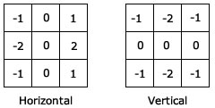

Laplacian kernel 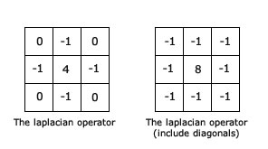

In final version I decided to use Laplacian kernel owing to the fact that it turned out to make more accurate edges on my tests.

Evolutional of lines

I decided to solve the problem in following way. Consider as individual segment on picture. Its genes are (x1,y1,x2,y2, thickness). Population - set of such segments.

**Mutation** - with some probability regenerate one or more parameters of particular individ.

**Crossover** - in crossover I took 2 parents (2 segments) and merged their parameters (genes) to create new child. However crossover neither improved the speed of convergence nor the speed of iteration. Therefore I decided not to use it in final version of generator.

**Selection** - selecting some portion of individs which will come to next iteration.

**Loss function** -this one is used to understand how each individual is good or bad. I have tested several loss functions for individs, including Mean Average Error, Mean Squared Error and Intersection Over Union. Although, all of them are appropriate for problem domain, IoU has the fastest convergence speed. Different results from metrics will be shown later.

The epoch itself:

1. Select portion of best individs from population by the loss function
2. Crossover them and create children
3. Mutate children
4. Assign best portion and children to new pop
5. Go to step 1 until reach appropriate loss

Results

1. IoU

Population 3000

Length of line 10-40



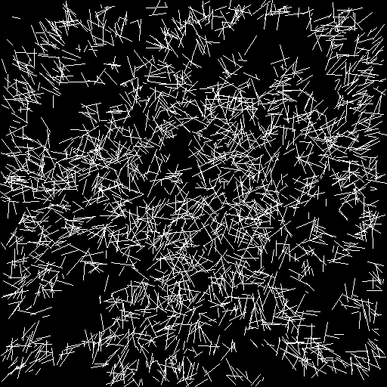

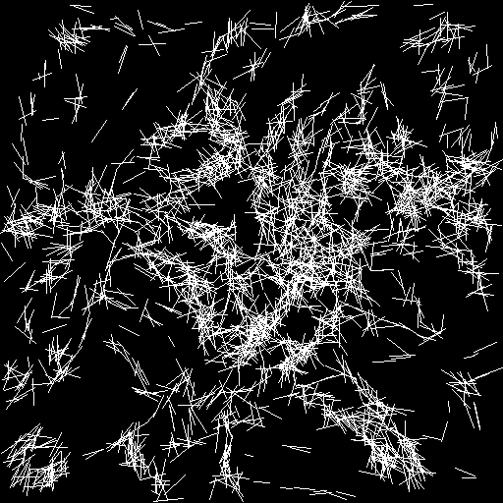

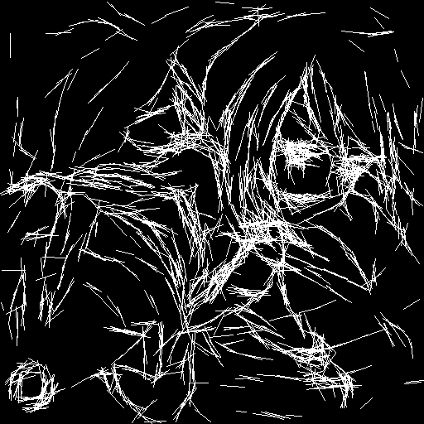

2. MSE

Population 4000

Length 1-5



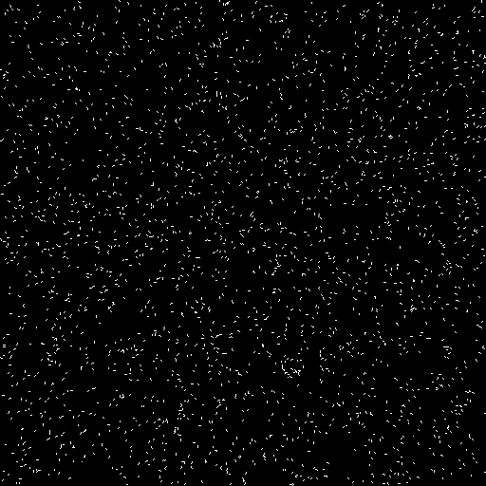

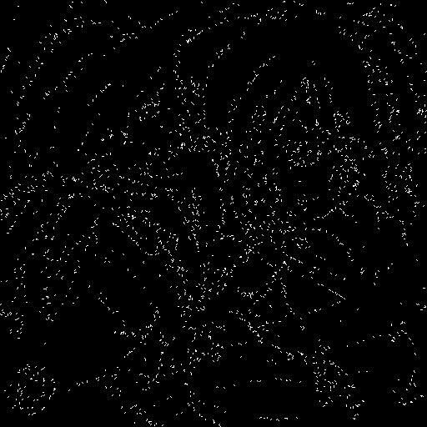

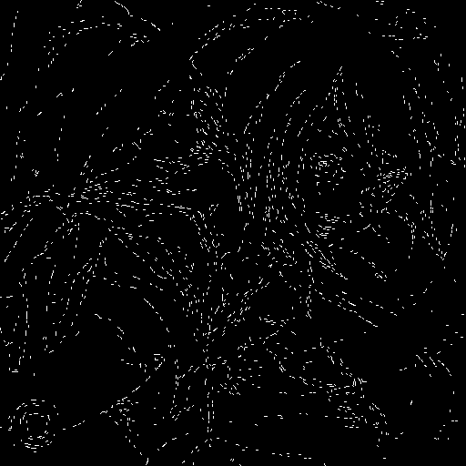

3. IoU

Population 5000

Length 5-20

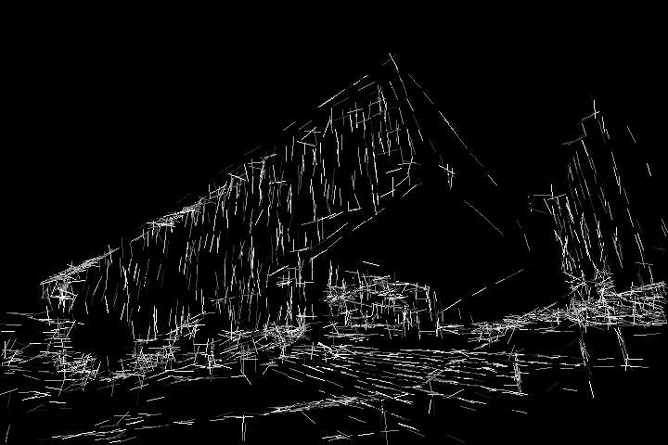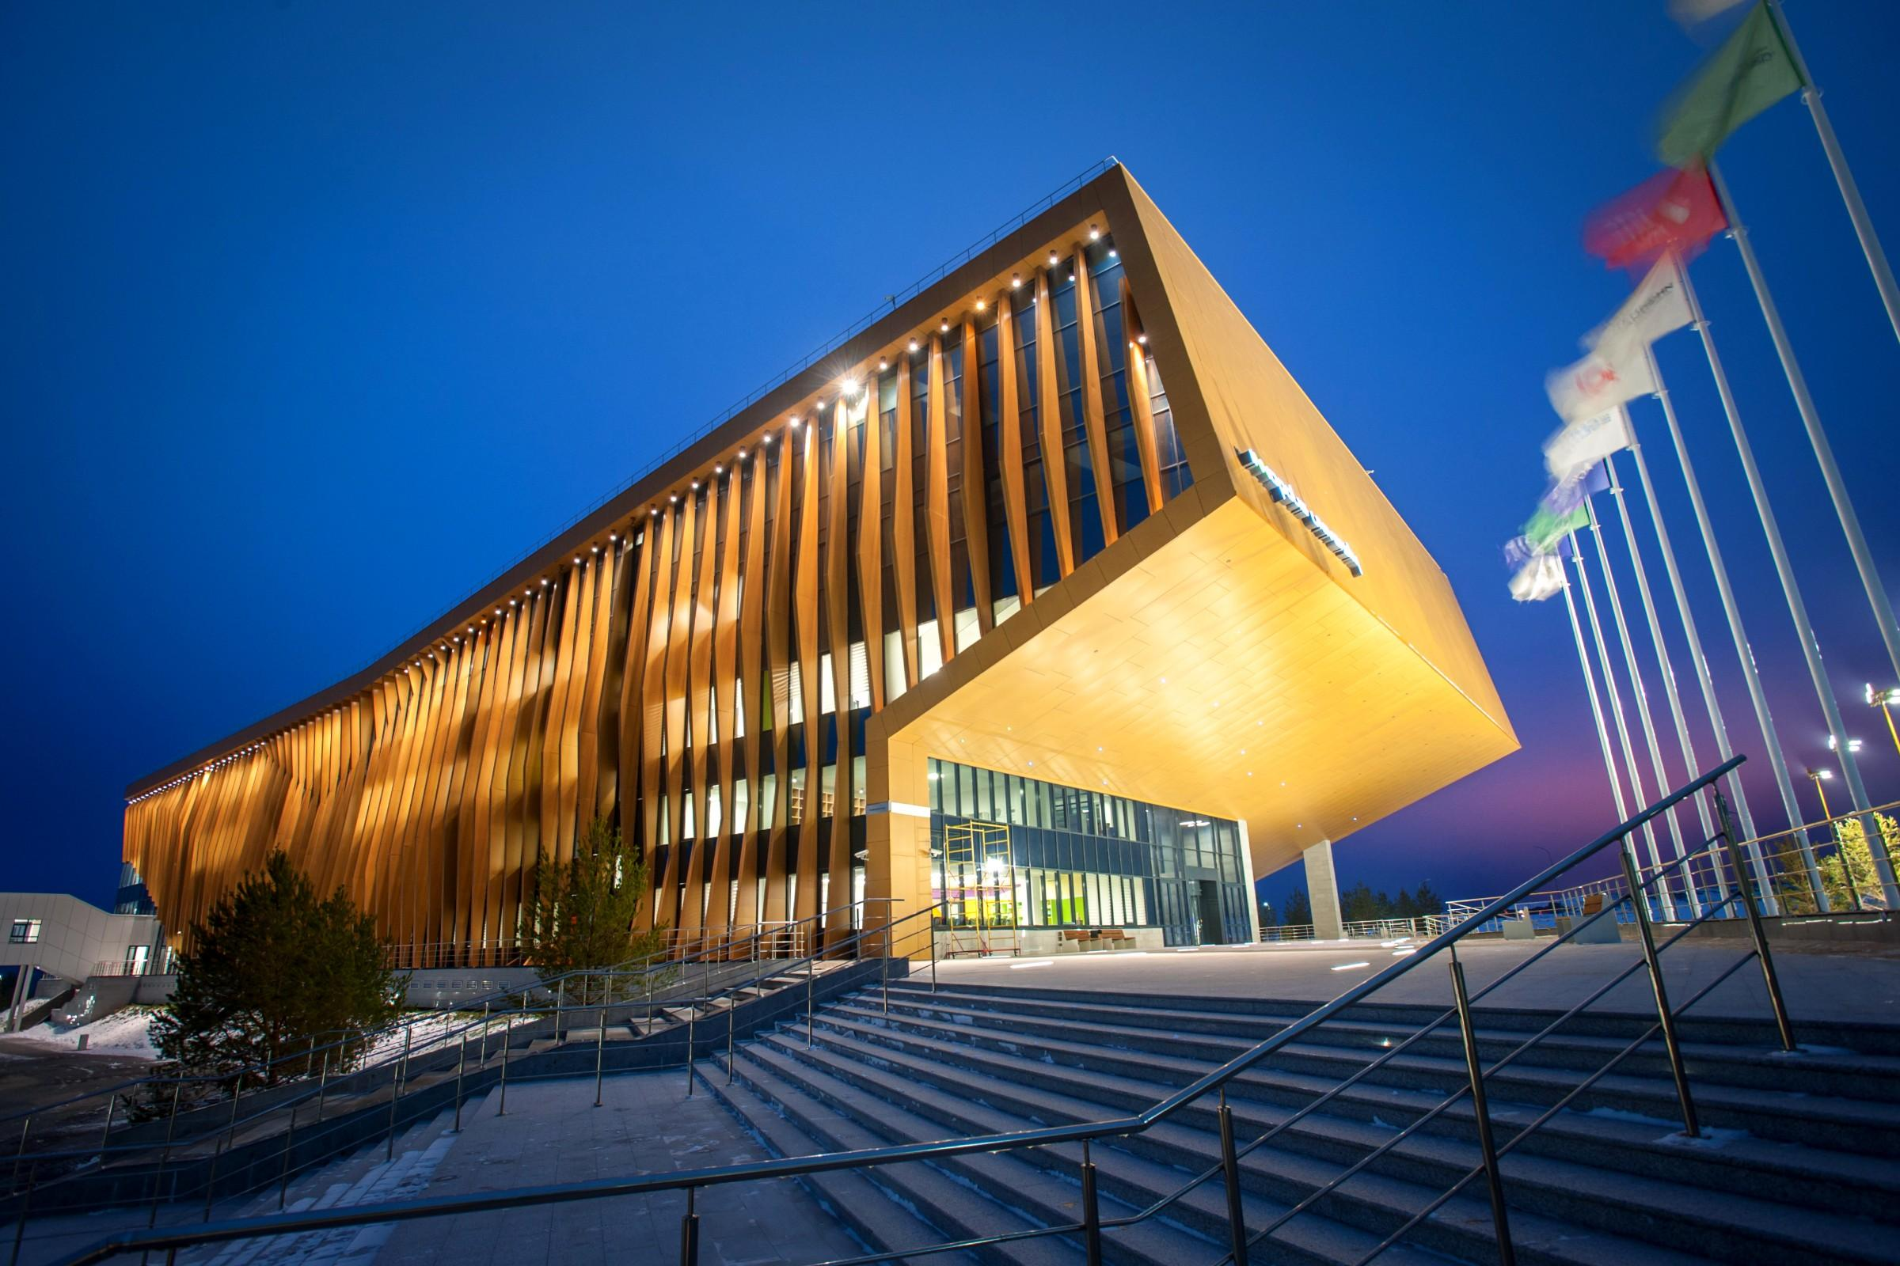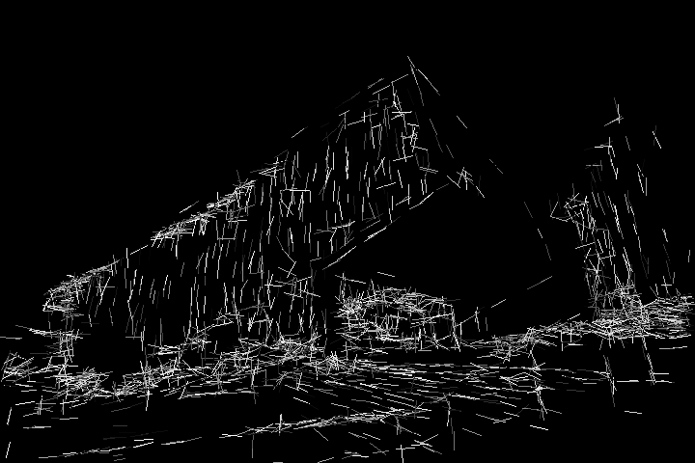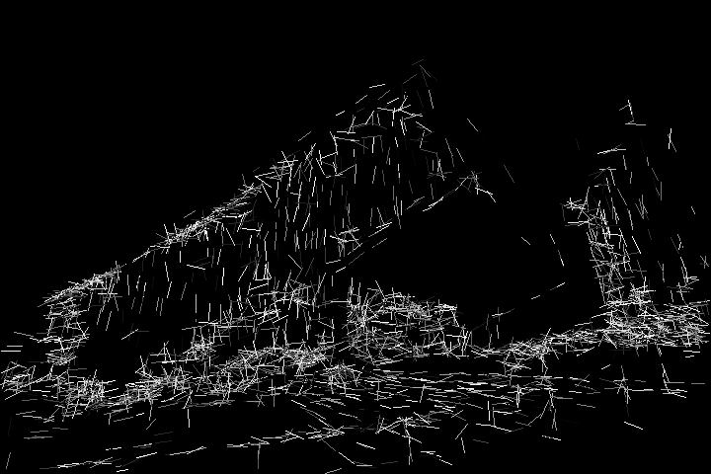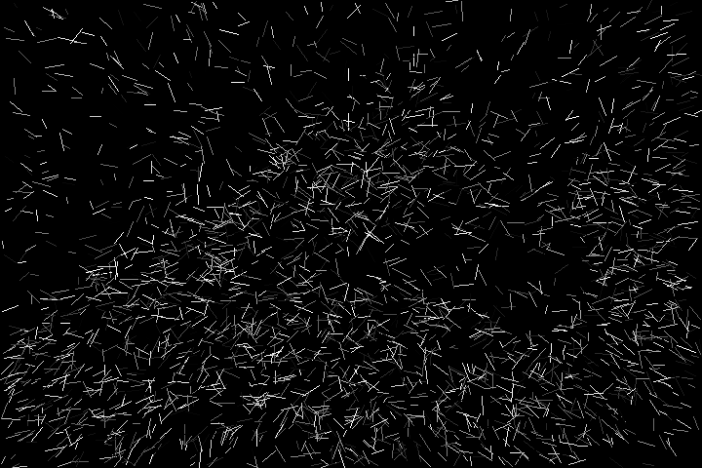



4. MSE

Population 5000

Length 5-20

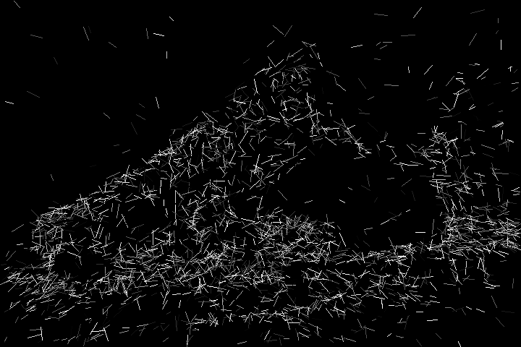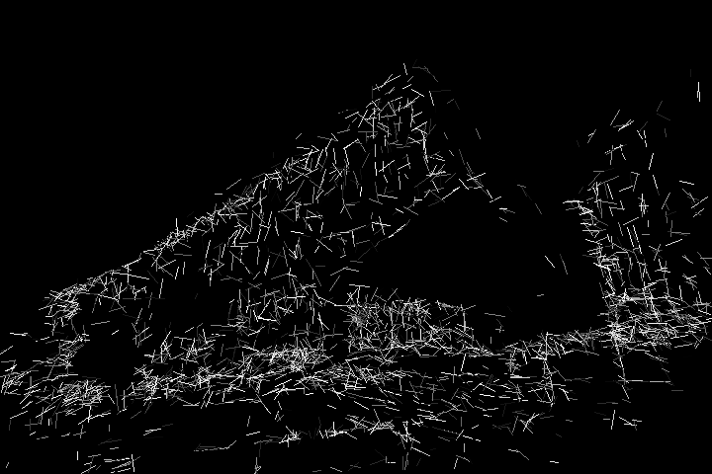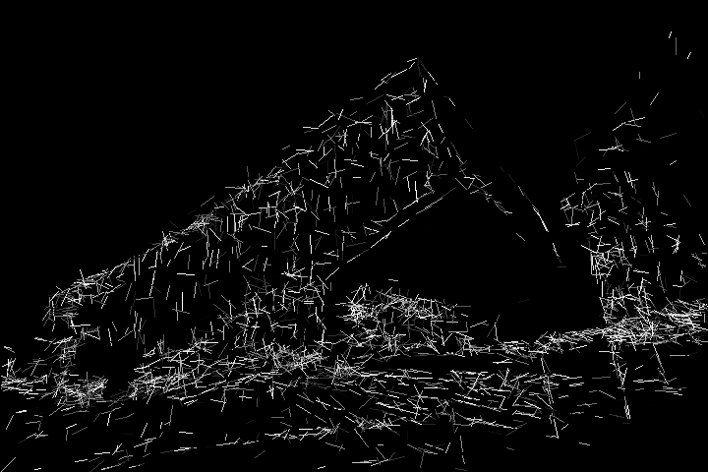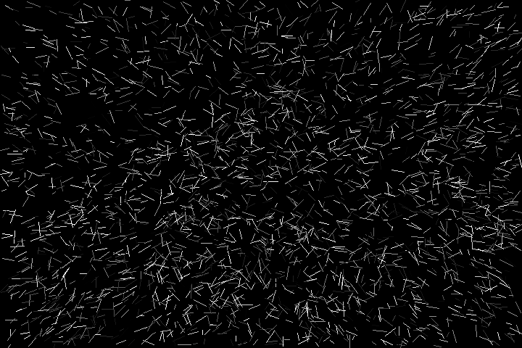

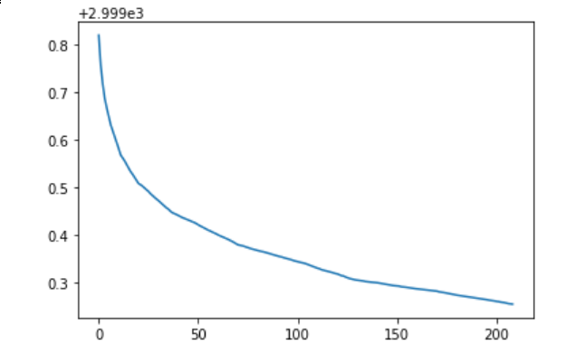

Conclusion

Evolutionary algorithms turned out to be efficient in drawing the arts. I considered this approach of evoluting the lines to be interesting and efficient. Still I think there are some things to be done in future:

1. Rewrite the code to using GPU to increase speed of iterations
2. Try some other metrics to evaluate the quality of picture
3. Investigate some techniques of effective crossover